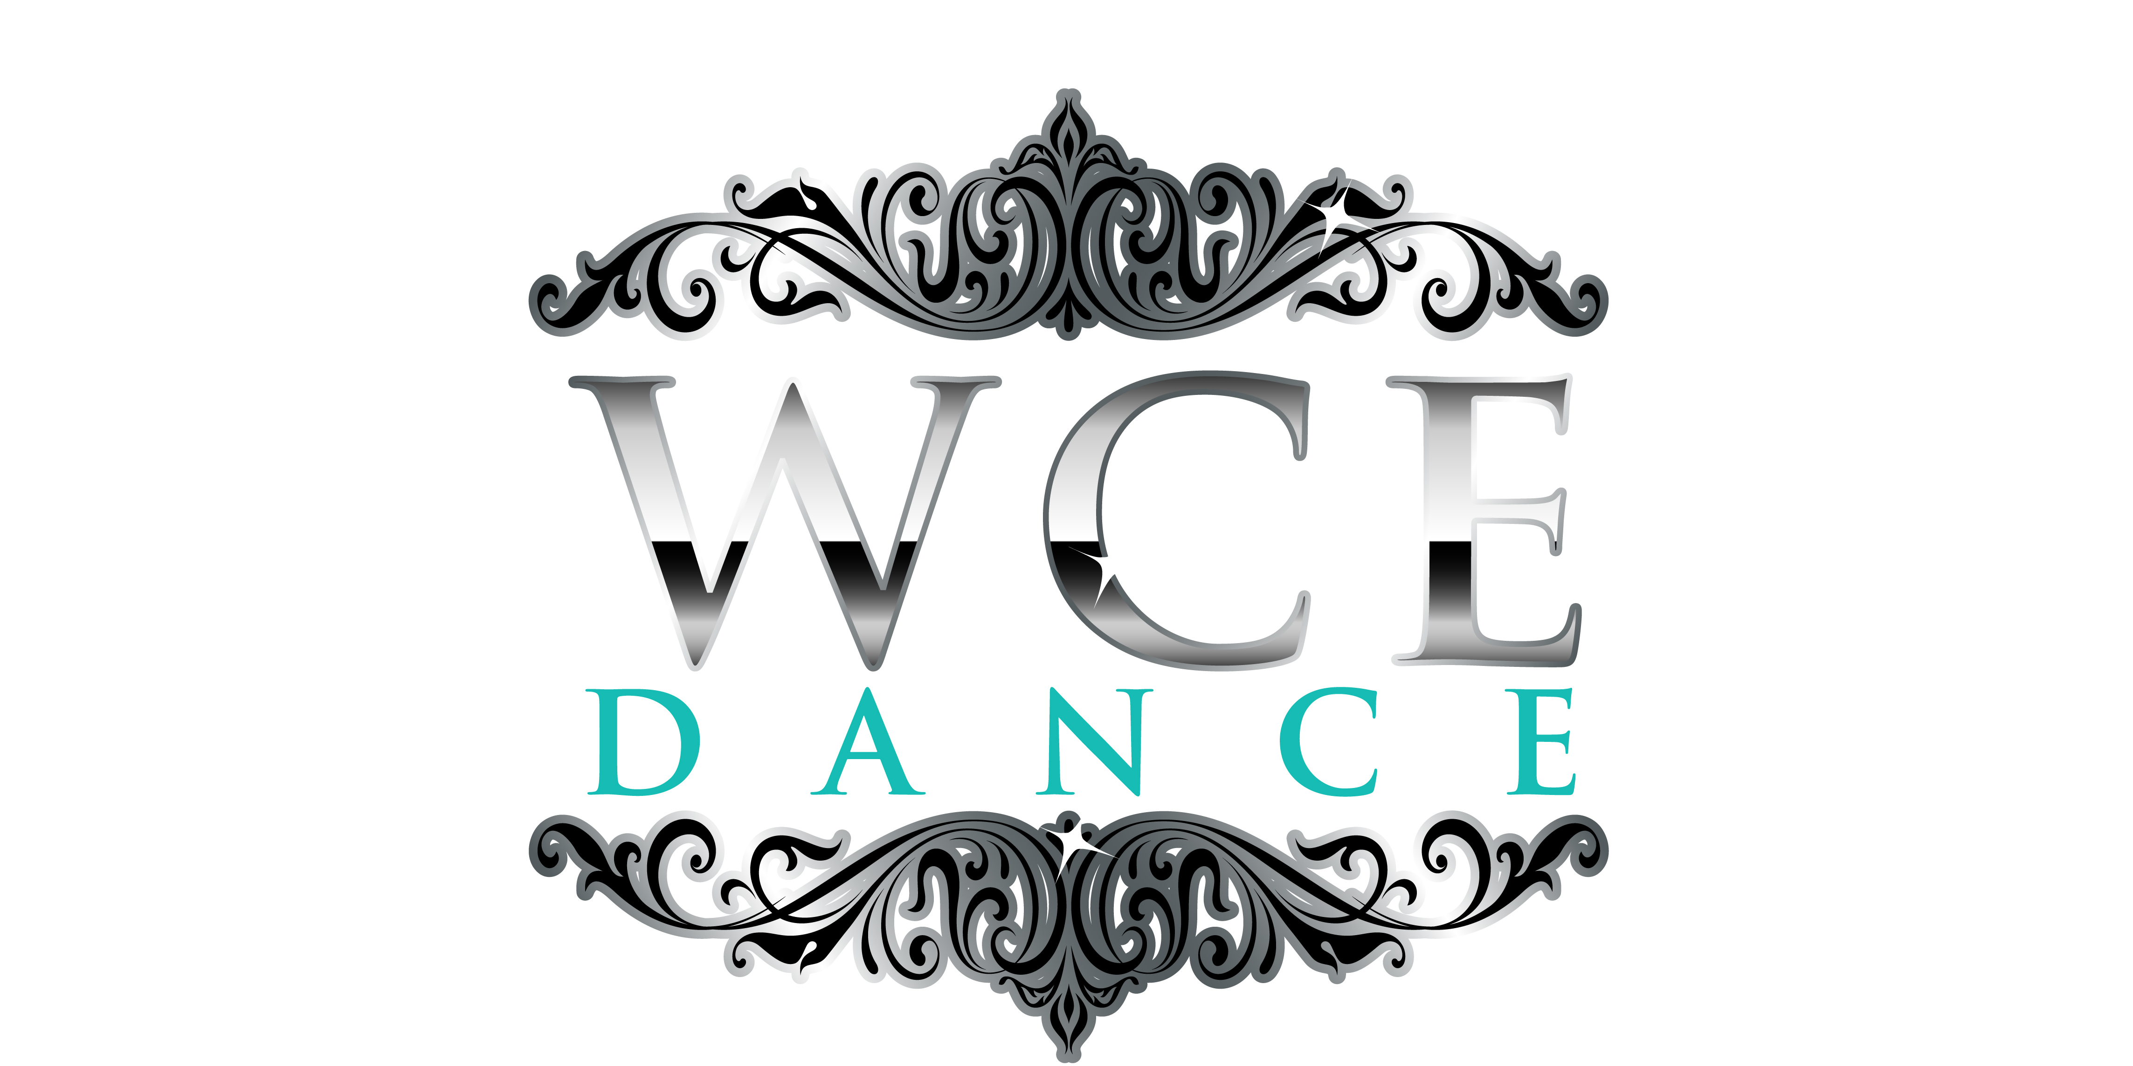
All Star Nationals
~ March 23-24, 2017 ~
Long Beach Convention Center
Arena
300 E Ocean Blvd.
Long Beach, CA 90802

Accommodations
For a discounted rate ($199/night), please reserve your room under the West Coast Elite Dance room block prior to February 23, 2018.
Long Beach Westin (most direct route to Arena)
333 E Ocean Blvd.
Long Beach, CA 90802
(800) 937-8461

Event Schedule
The following schedule is subject to change based on registration:
Friday Competition- 8am-9pm- solos, improv, solo finals
Saturday Competition- 8am-5pm- all team dances
Closing Gala Show- 5:30pm

National Awards
Grand Champion: The 2018 All Star National Grand Champions will receive $1,000! First and second runner up will also receive cash prizes. In order to qualify for this award, a minimum of four team dances must be competed. The four highest scoring routines per team will be averaged together. The team with the highest average will be awarded the title of WCE National Grand Champions. The 2018 National Grand Champions will be invited to perform in our closing Gala celebration.
Top Overall: Will go to the highest scoring dance in the competition. 2nd through 10th place Overall will also be awarded. Cash prizes will be awarded for 1st-5th place.
Best In…: Awards will be given to the highest scoring entries in Hip Hop, Lyrical, Jazz and Contemporary.
Judges’ Pick: Judges will select dances that stood out in both the silver and gold levels. Awards include: choreography, entertainment, technique, storytelling, commitment, and performance.
~ Awards will also be given for placement in categories. ~

Solos
We accept UNLIMITED solos! Dancers are permitted to enter more than one solo, however, only the highest scoring solo from each dancer will be eligible for placement. The categories will be divided by grades. The top ten soloists (regardless of grade) will compete again that evening for scholarships, and the title of WCE Dancer of the Year. (Awards per individual categories will also be presented). The 2018 Youth National Dancer of the Year will be invited to perform in our closing Gala Saturday evening.

Improv
West Coast Elite Dance is thrilled to offer this inspiring category! Dancers are asked to leave their heart on the floor, and push their creativity to the limits. Before taking the stage, dancers will not know which song they are dancing to. West Coast Elite Dance will provide the music. All improv entries will be one minute in length.
Solo- On the Registration Form simply list the preferred style. You may choose between Contemporary and Hip Hop.
Contact Improv- All entries must be 2-3 people. On the Registration Form simply list the preferred style. You may choose between Contemporary and Hip Hop.

Breakdown of Divisions
Elite: Any dance style or form of dance is acceptable.
Jazz: Any form of jazz dance is acceptable
Contemporary: A routine that rejects the limitations of classical ballet and favors movement deriving from an abstract source.
Lyrical: A fusion of ballet and jazz techniques. Lyrical routines express deep emotion or observations, derived from the lyrics or feeling of the song.
Large: Any dance style or form is acceptable.
Open: A dance may only be competed in Open if it does not fit into any other division. I.e. a normal lyrical routine may not be competed in Open. Open is reserved for Prop and Novelty routines that do not fall under other division guidelines.
Character/ Broadway: By use of choreography, costuming, and performance, the dance must convey a complete character, or revolve around a Broadway theme.
Hip Hop: Alternates fast paced sharp actions that involve body popping, and locking, with slower movements and freezes.
All Male: Any dance style or form is acceptable. All must be male.
Co-ed Dance: Routine must have male and female participants, and can be any style of dance.
Kick: Majority of routine must be focused on kick combinations.
Pom: Poms must be used for atleast 50% of routine.
Military: Routine emphasis is on precision dance movements, with sharp clean visuals.

Pricing
Please see All Star Nationals Registration Form for pricing information.

Admission
Full weekend Pass advance purchase (before February 23, 2018)- $45
*Available through team registration only
Full weekend Pass after February 23, 2018 (includes Friday competition, Saturday competition & closing Gala)- $50
One day competition only- $25
Children 6-10 - $25 (full weekend pass)
Children 6-10- $10 (one day competition)
Children 5 & under- Free
* Only cash or check accepted at the door. Credit cards not accepted for admission.

Performance Area
The performance area for all team entries at Nationals is a regulation sized basketball court. Solos and improv entries will be on a ballroom floor. Dimensions TBD.

Eligibility
All Star Nationals is open to competitors from Pre-K though 12th grade.

Judges
As West Coast Elite is dedicated to pushing forward with today’s dance trends, it prides itself on having 100% of its judges be current working professionals in the dance industry.

Music
Please upload all music for Nationals by March 13, 2018. Please make sure that you are uploading music to the correct corresponding routine. NOTE ALL FILES MUST BE IN MP3 FORMAT. Please bring an iPod for backup.
Safety Guidelines and Appropriateness
Please use discretion to ensure dancers’ safety when using lifts, stunts and mounts. Inappropriate movements, music, and explicit lyrics will result in a 5 point deduction per infraction.

Props
All props must be non-marking, and have rubber, padding, or wheels. Props must be able to be disassembled to fit through a doorway. No props are permitted to be stored in the performance area. Violation of guidelines for props will result in disqualification. Teams will be held liable to any damage done to performance area or property.

Shoes
All shoes must be non marking. Bear claws, foot thongs, and bare feet are permitted.

Insurance
Each participant is required to have his/her own insurance, which must be shown on the WCE Dance, Inc. Medical Release. The host school, host school district, and West Coast Elite Dance, Inc. will not be held responsible for any injuries occurring at the 2018 WCE Dance Championships. If a participant fails to turn in a completed 2018 WCE Dance, Inc. Medical Release they will not be permitted to compete. All medical release forms will be due the day of the competition.

Registration
Registration is due February 23, 2018. You may register online at westcoastelitedance.com or mail in your registration. The Registration Form and full payment, will be due at this time. School check, personal check, cashier’s check, school purchase order, money order and credit card are all acceptable forms of payment. The fee for a bounced check is $35. In order to run a smooth and organized competition, WCE will not be able to accommodate any changes to categories the day of the event. All changes must be made at least two weeks prior to the competition.
Late Fee: A $100.00 late fee will be accessed to any teams whose registration form reaches the WCE office after February 23, 2018.
Waiting Lists: If the WCE National Championships reach capacity then every school registered thereafter will be put on a waiting list. Please be aware that registration may close even before the final registration deadline.
Refunds: Absolutely no refund or credit will be given within four weeks of Nationals. WCE will provide a credit to any entries dropped prior to four weeks from the competition.
Note: The competition order will be determined by the order in which registration forms and payment is received. Early registration is advised.

